#### **Remove in BST**

* First of all, we need to find the element that we want to eliminate.
* Then we start the removal steps:
  + If the node we want to delete is a leaf, we can just delete it.
    - * Eg. _remove(20)

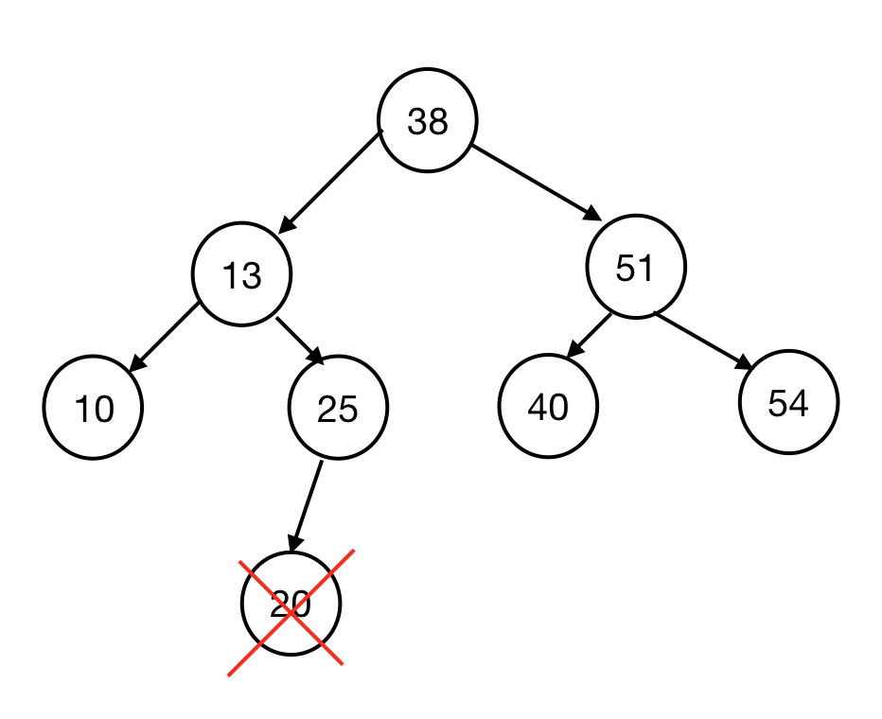

* + If the node we want to delete has only one child, we can delete as like in the linked list - just replace that node with its child.
    - * Eg: _remove(25)

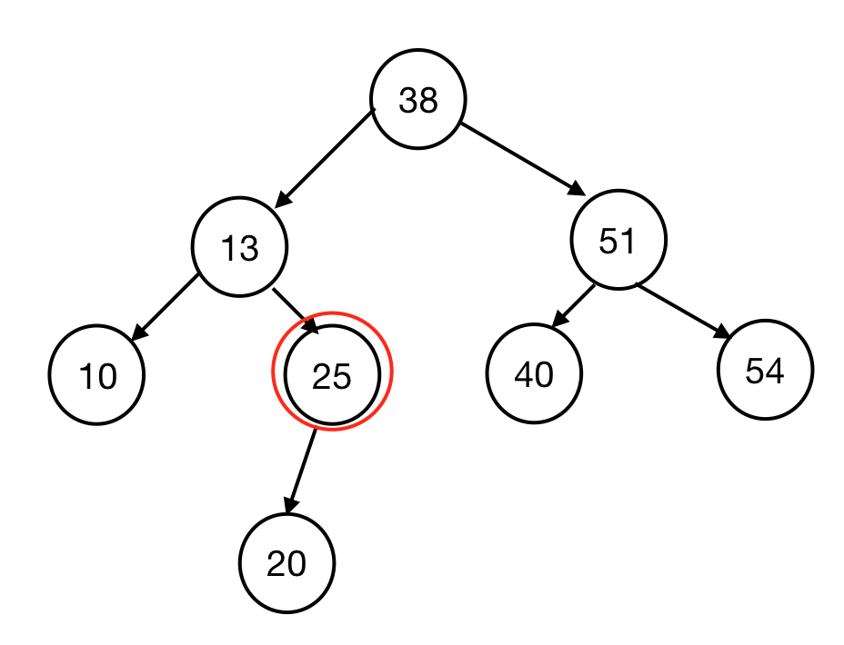 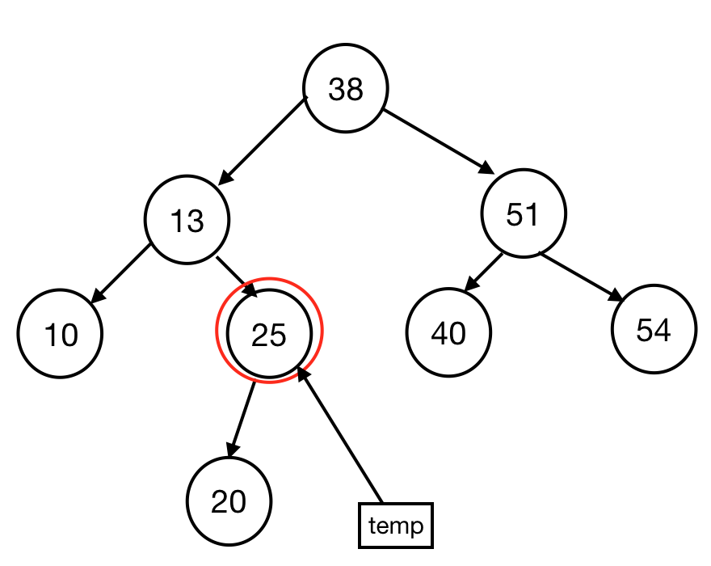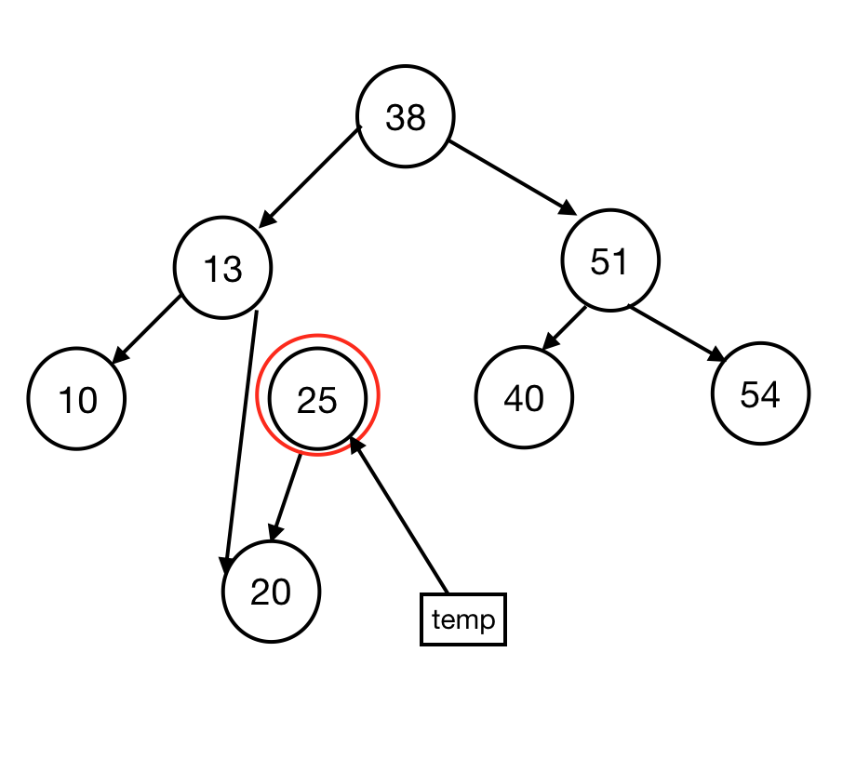 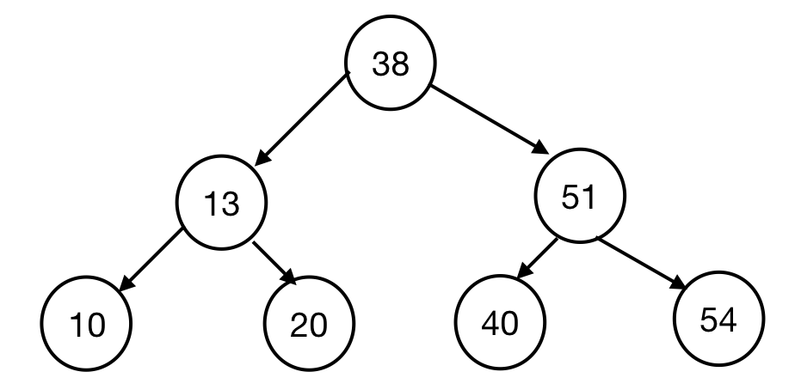

* + If the node we want to delete has two children:
    - First to find inorder predecessor (IOP) - the largest node in the left subtree (the rightmost node of the left subtree)
    - Swap IOP and the node we actually want to delete
    - The node is now a leaf, so we can remove it.
      * + Eg: _remove(51)

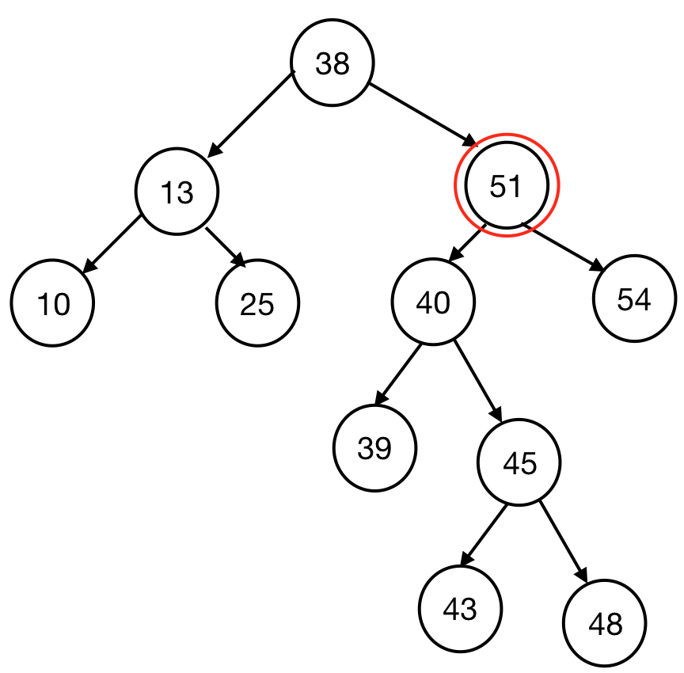 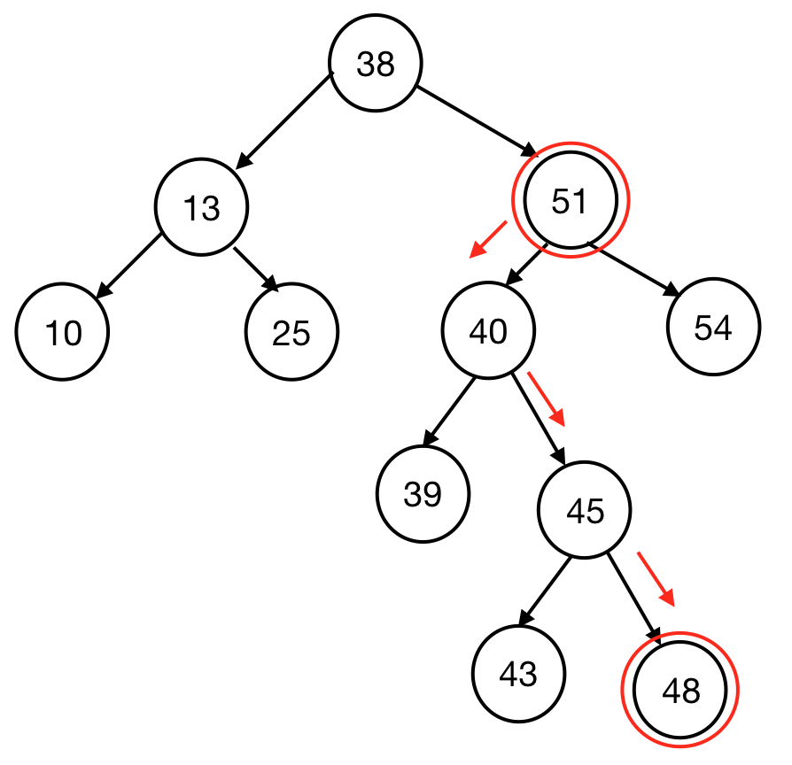

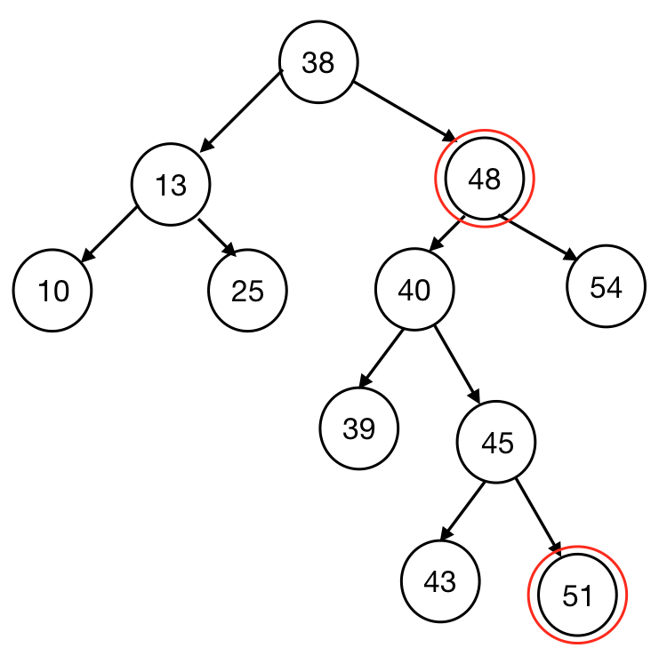

* Find / insert / delete : O(h)

#### **The relationship between H and N**

* We observe every operation on BST in terms of the height of the tree.
  + m(n) = max number of nodes   
     = {0, h = -1  
     1+2m(h-1), h > -1  
     = 2h+1 - 1 //O(2h)
* **Proof by induction**
  + Base case: m(0) = 20+1 - 1 = 2 - 1 = 1
  + Inductive step: m(h) = 1 + 2m(h -1)  
     = 1 + 2(2(h-1)+1 - 1)  
     = 1 + 2 * 2h - 2 = 2h+1 - 1
* Therefore we have (2h+1 - 1) ≤ n. By solving it we have h ≤ log2(n+1) - 1
* The height of the tree depends on the order of which data to insert
* For every BST, O(log n) is the lower bound running time and O(n) is the upper bound running time.